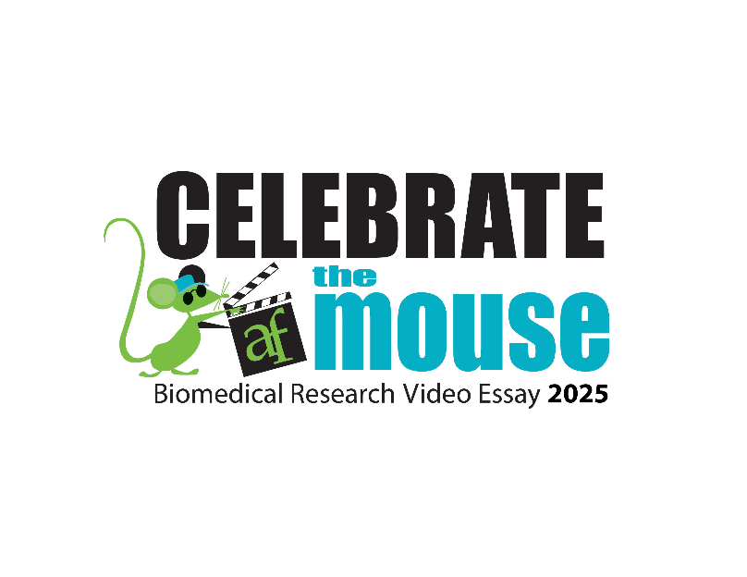

**Enter the AALAS Foundation’s 2025 Celebrate the Mouse Biomedical Research Video Essay Contest!**

Calling 5th through 12th grade students!

Enter the “Celebrate the Mouse Video Essay Contest” and share your knowledge about how mice have helped advance major medical discoveries.

Eligible contestants will have the opportunity to earn **CASH AWARDS** by creatively producing a video essay to show how mice in research have helped the lives of people and/or animals.

**The Challenge**: Create an original video essay explaining how you, a family member, friend, or pet have benefited from medical discoveries made possible thanks to work conducted with mice in biomedical research.

Visit <http://kids4research.org/fun-stuff/Celebrate-the-Mouse-Video-Essay-Contest> for Official Rules and how to enter.

**Contest begins September 1, 2025. Entries must be received by January 31, 2026.**

This contest is open to all legal residents of the United States or District of Columbia who are registered students in grades 5 – 8 or grades 9 -12. Every student is eligible: public, parochial, private/independent, home-school. NO PURCHASE NECESSARY TO ENTER CONTEST.

Questions: Email foundation@aalas.org